The OpenCV Pipeline

Architecture Diagram
The diagram below represents the full end-to-end architecture of the pipeline, showing how data flows through each of the seven stages from raw input to final output.

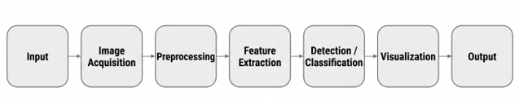

1. Input
The pipeline begins with raw visual data — an image, a video stream, or live camera frames. At this stage, the data is unprocessed and may vary widely in resolution, lighting, orientation, and format. The quality and nature of this input directly constrains everything downstream; no later stage can recover information that was never captured.

2. Image Acquisition
This stage covers how the visual data is actually obtained and brought into the system — reading a file from disk, capturing frames from a webcam, or streaming video from an external source. In OpenCV, this is handled through functions such as cv2.imread() and cv2.VideoCapture(). Acquisition also includes basic sanity checks: confirming the image loaded correctly, verifying its dimensions, and standardizing its format (e.g., converting to a consistent color space) before further processing.

3. Preprocessing
Raw images are rarely clean enough to analyze directly. Preprocessing improves image quality and removes noise so that later stages can work reliably. Common operations include grayscale conversion, resizing, normalization, blurring (Gaussian or median), histogram equalization, and thresholding. This stage is often the difference between a robust pipeline and one that fails on real-world, imperfect data.

4. Feature Extraction
Here, the system identifies meaningful patterns within the image — edges, corners, contours, textures, or keypoints — that describe its structure. Traditional techniques include Canny edge detection, Harris corner detection, HOG, and SIFT/SURF descriptors; deep learning approaches instead learn hierarchical features automatically through convolutional layers. These extracted features become the compact representation that detection and classification models actually operate on, rather than raw pixels.

5. Detection / Classification
This is the core decision-making stage. Detection locates and localizes objects within the image (e.g., bounding boxes via YOLO or Faster R-CNN), while classification assigns a label describing what the object is (e.g., a CNN predicting 'car' or 'dog'). Some systems combine both — detecting where objects are and simultaneously classifying what they are — while others perform pixel-level segmentation to determine object boundaries precisely.

6. Visualization
Raw model outputs — coordinates, class labels, confidence scores — are not human-readable on their own. Visualization overlays this information back onto the original image: drawing bounding boxes, labels, masks, or keypoints so a person can interpret the result at a glance. This stage is critical for debugging, demonstrations, and any system where a human needs to verify or act on the output.

7. Output
The final stage delivers the processed result to its destination — saving an annotated image, returning a JSON response from an API, triggering an alert, logging data to a database, or feeding results into another downstream system. The output format depends entirely on the application: a research notebook might simply display the image, while a production system might send structured data to a mobile app or dashboard.

